SAP BAP - ASN0000453:
SAP SCM APO (BAP) HBT/SPS PROD:
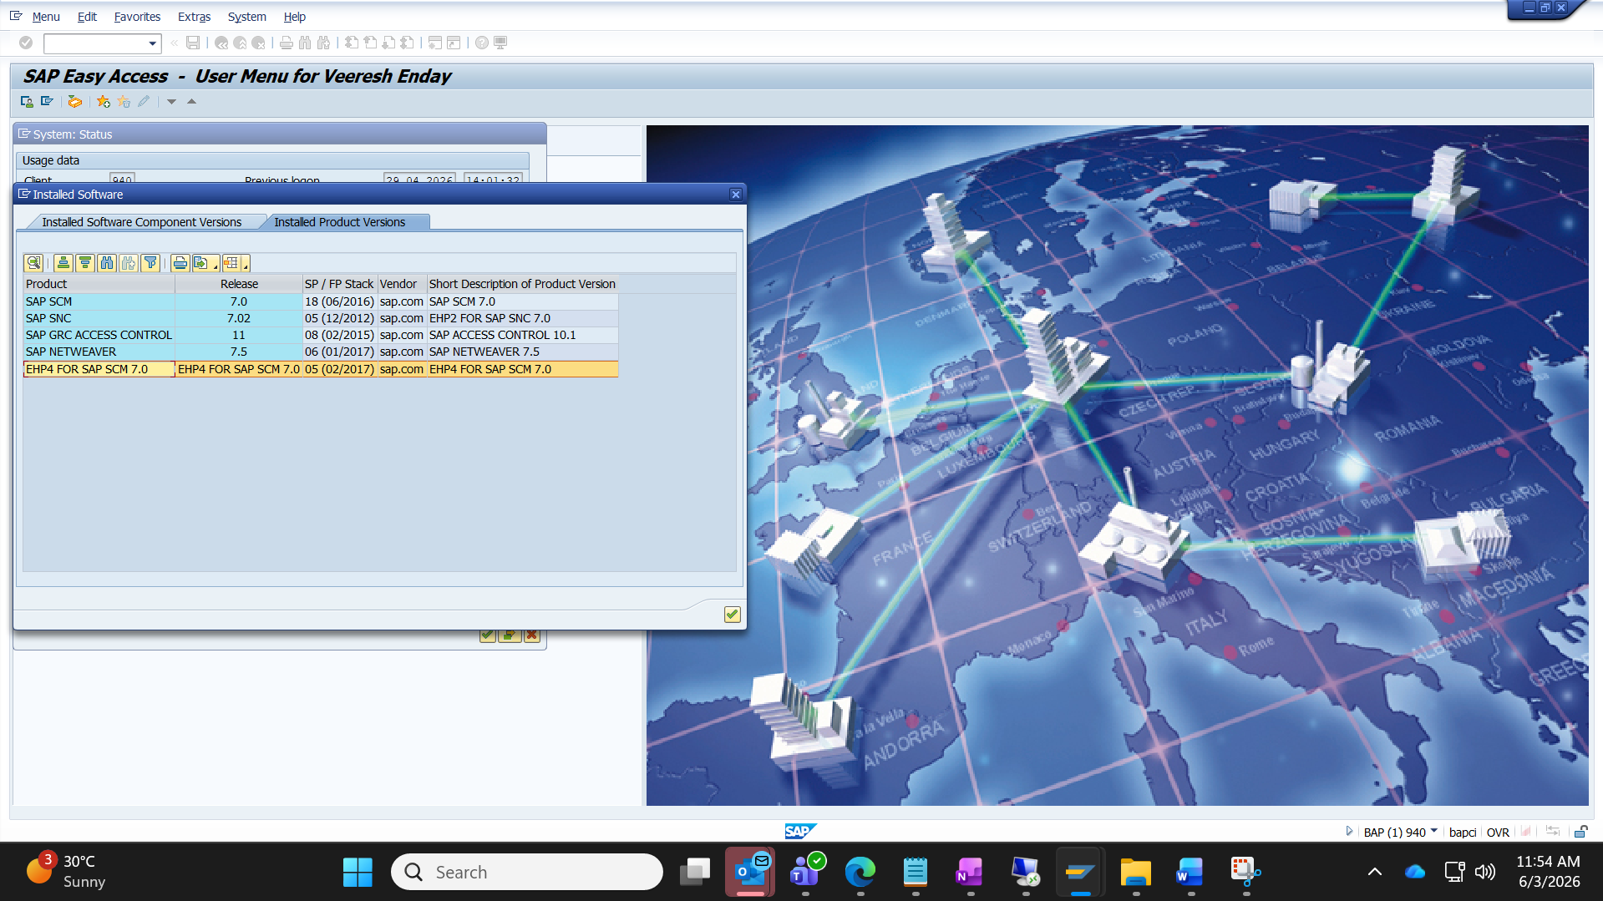
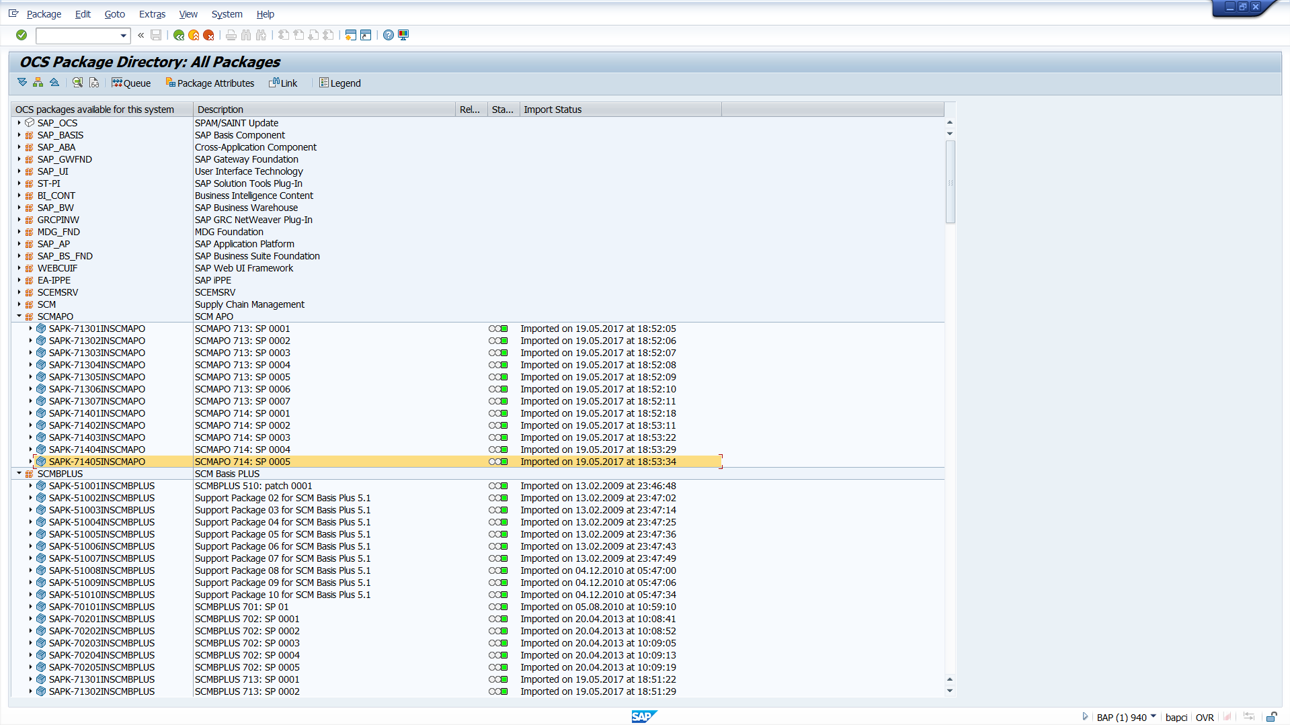

SAP Support End of Mainstream Maintenance: 31.12.2027

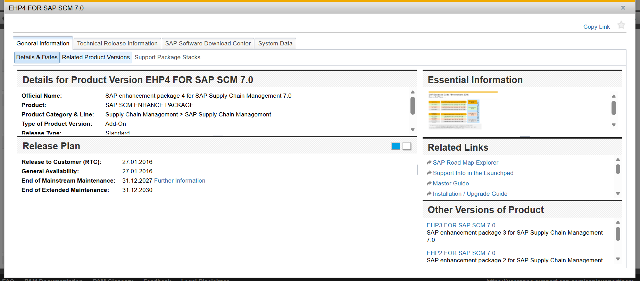
Latest patch available is 25:
